**PROJECT COVID INFO INSTALLATION GUIDE**

Contents

2 Database installation: 2

3 API WAR package deployment on tomcat 4

4 Running the Web components of the system 7

5 Running android Components of the system 9

# Database installation:

1. Open your MySQL database management software(We used phpmyadmin as an example)
2. Create database with the name covid with charset utf8_vietnamese_ci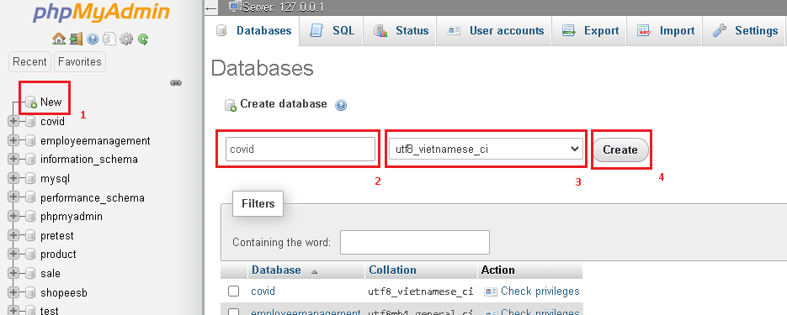
3. One finished click on import 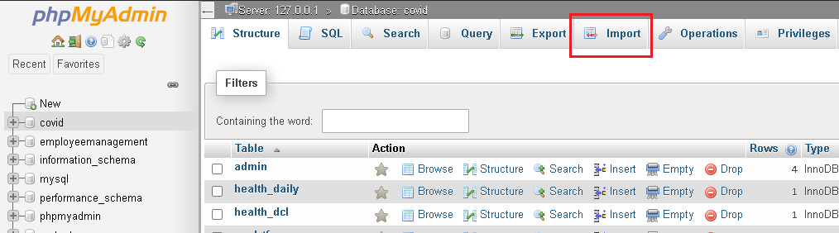

1. Click on choose file and select the SQL file name covid in our project folder, remember to check on Enable foreign key checks and click go

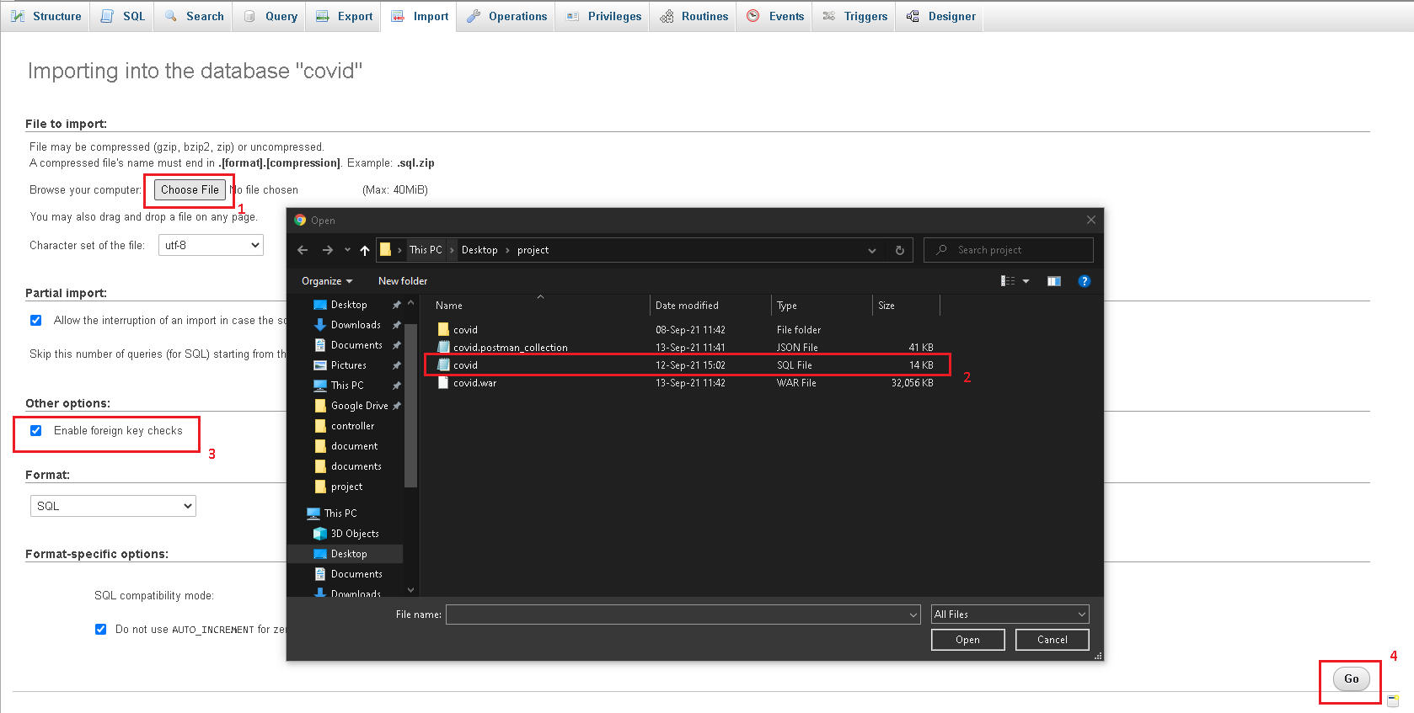

1. A message should pop up confirming the import has been successful along side with new tables

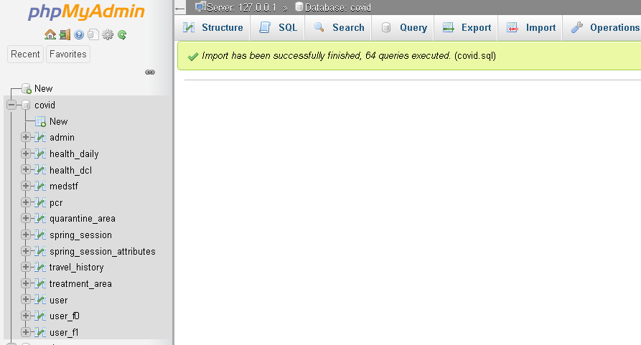

# API WAR package deployment on tomcat

* 1. Download and install Xampp here: <https://www.apachefriends.org/download.html>
  2. Open Xampp-control and start up Apache, Mysql and Tomcat Service then open Tomcat Admin

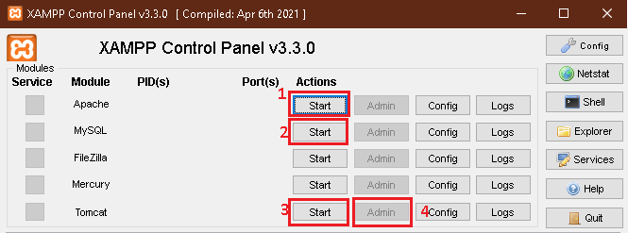

* 1. Once Tomcat admin page shows up click on Manager App

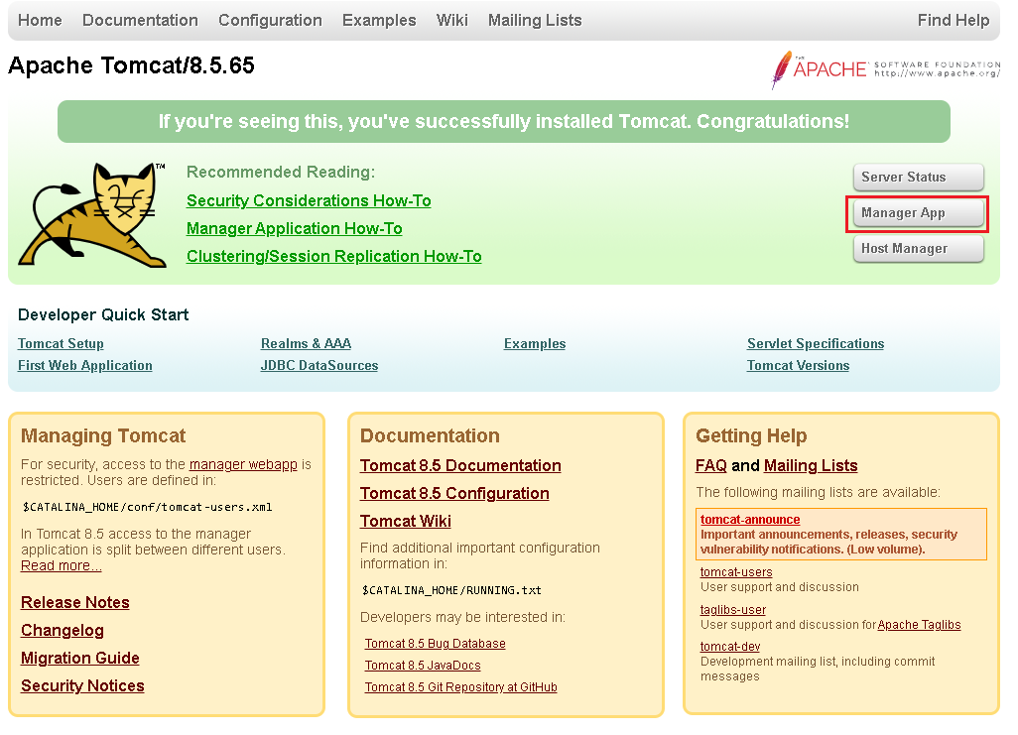

* 1. Sign in using Tomcat manager account. Follow this instruction to set up a tomcat manager account: <https://tomcat.apache.org/tomcat-7.0-doc/manager-howto.html>

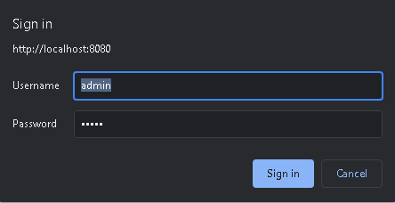

* 1. Navigate to WAR file to deploy tab and choose the war file form our project folder and click deploy

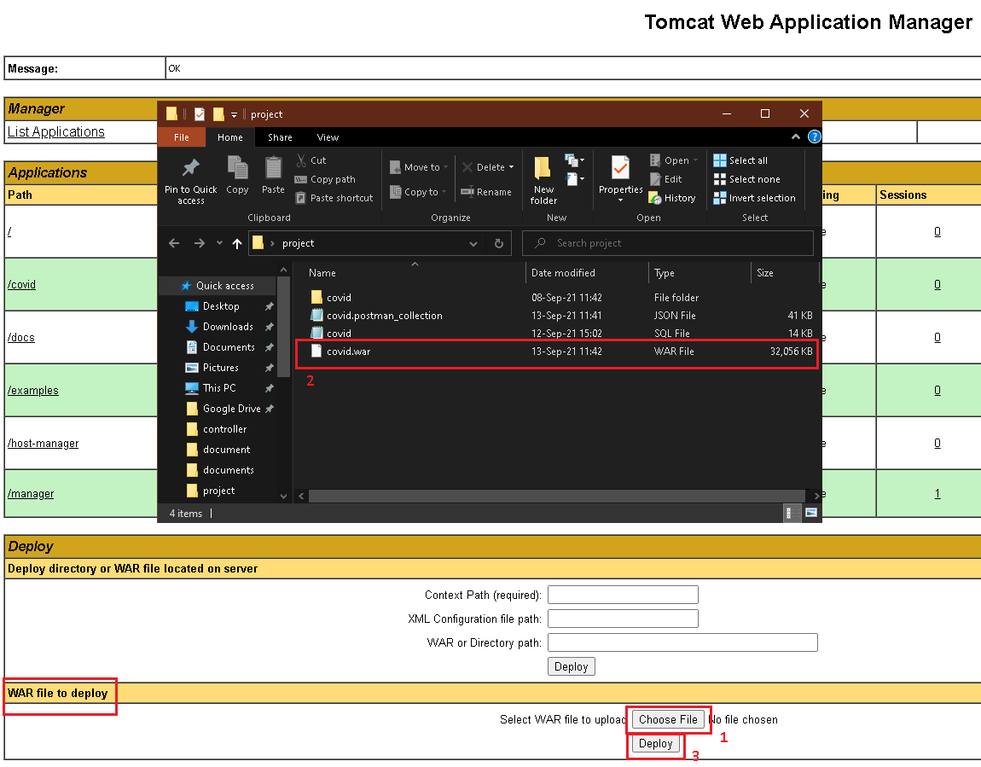

* 1. The application covid should show up on the Application list once deployment is successful

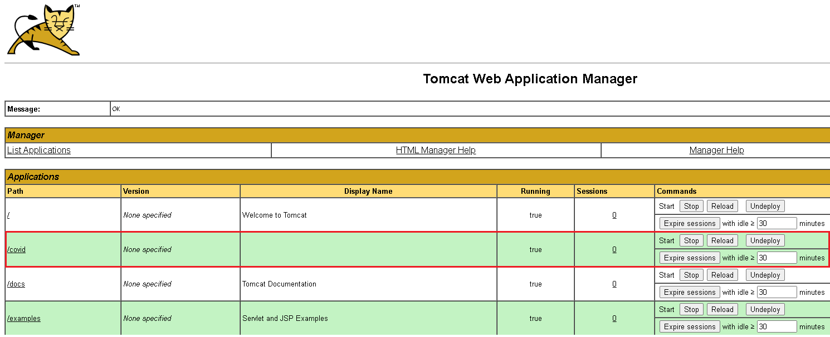

# Running the Web components of the system

1. Download and install Nodejs following this link: <https://nodejs.org/en/>
2. Copy the web components and paste it to some folder that you can easily navigate

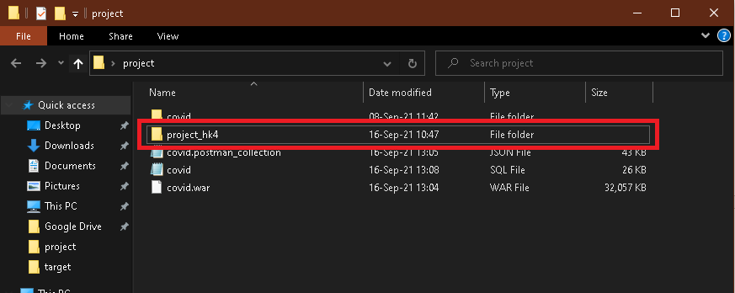

1. Start up xampp-control along with its services



1. Open cmd and navigate to the web components location and then type npm start

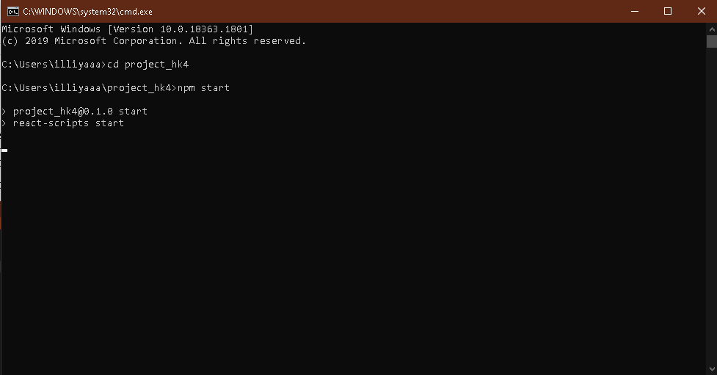

1. The web component should start successfully and navigate you to the log in page

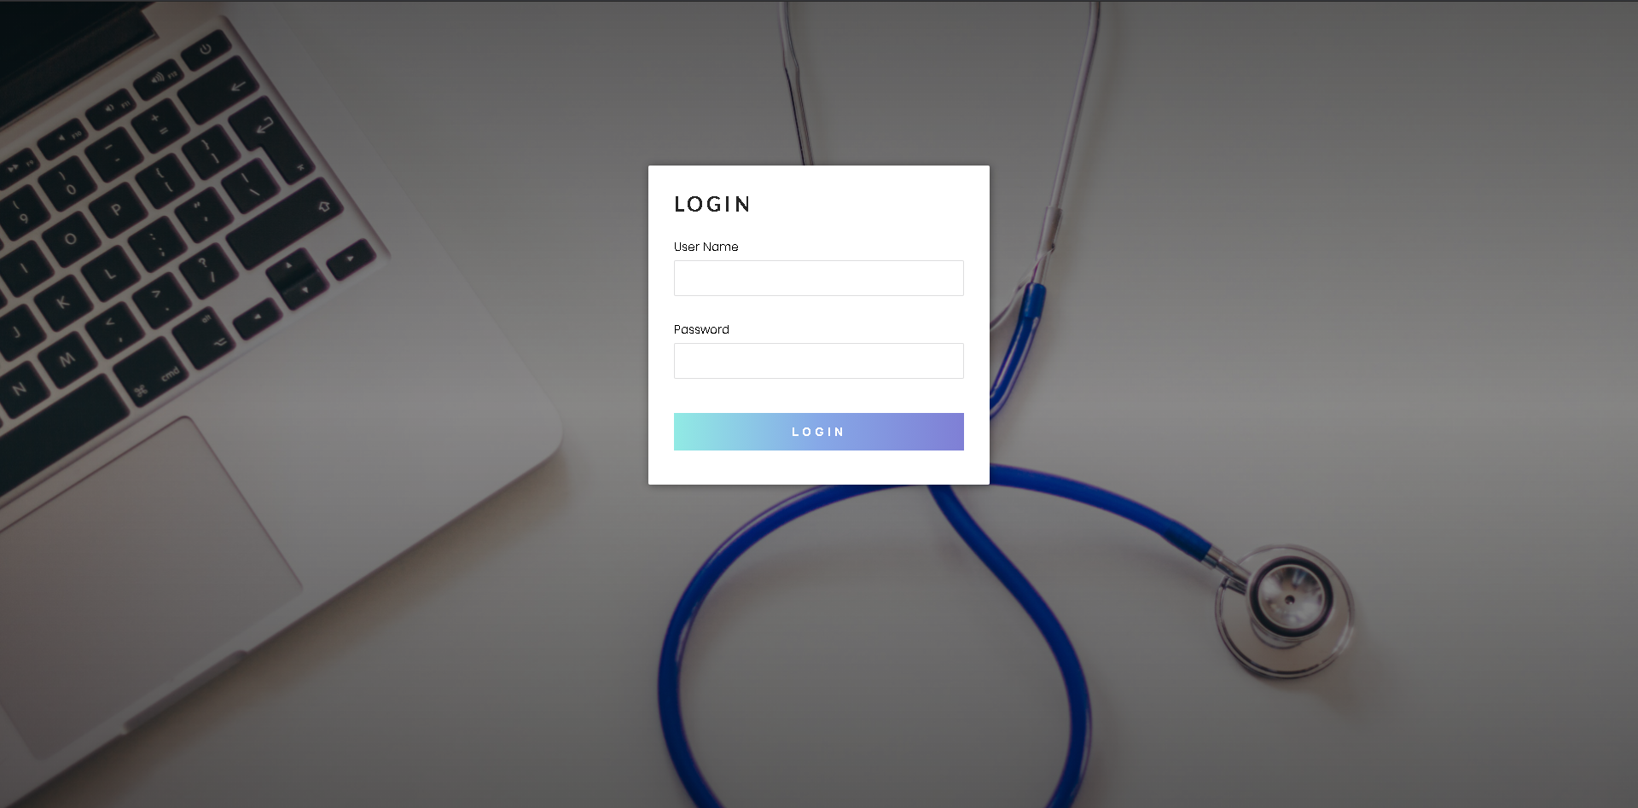

# Running android Components of the system

While our app run perfectly fine on an Android phone, to run it on an Android emulator and use Firebase OTP on your machine you need to configure some part of the Android components

1. Open the Android components on Android Studio

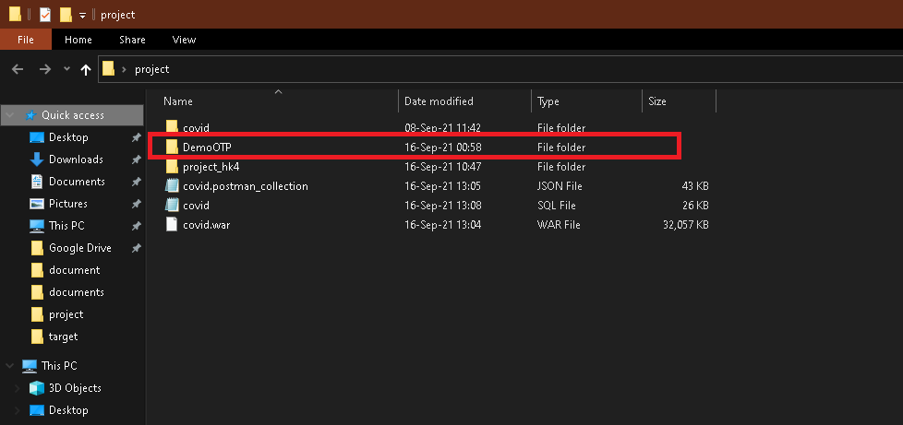

1. Navigate to the ApiService.java file and change the ipv4 of the url on line 37 to your machine ipv4

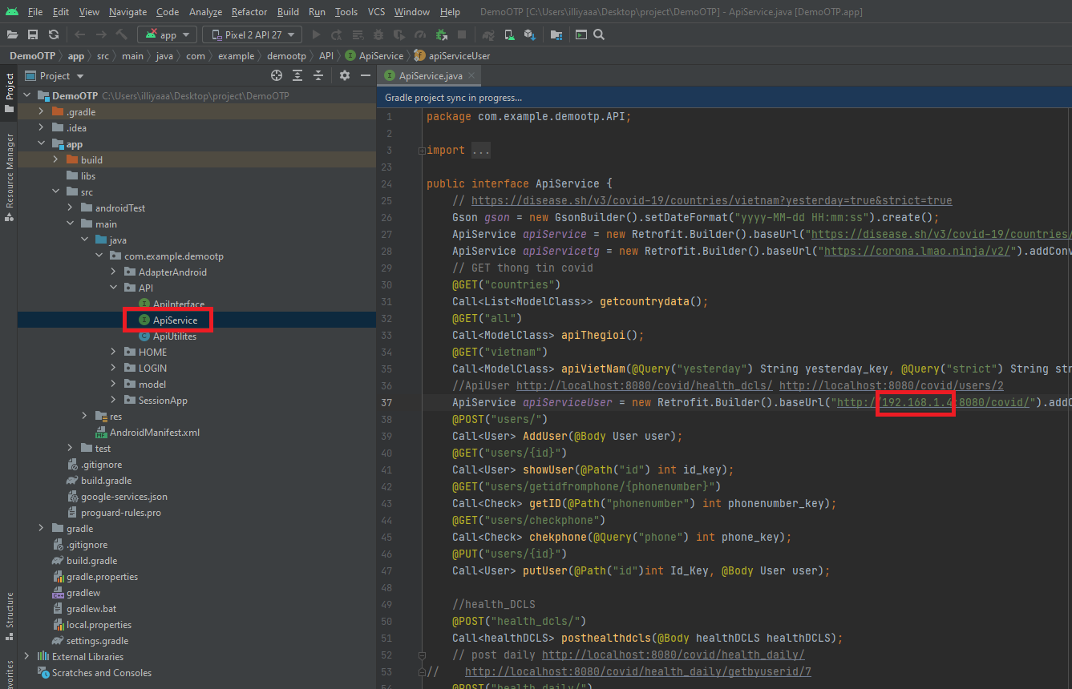

Now you can run our project on an Android emulator.

1. To use Firebase OTP on an emulator you need to first register a Fire Base account following this link:

<https://firebase.google.com/>

1. Afterward you need to create a new project

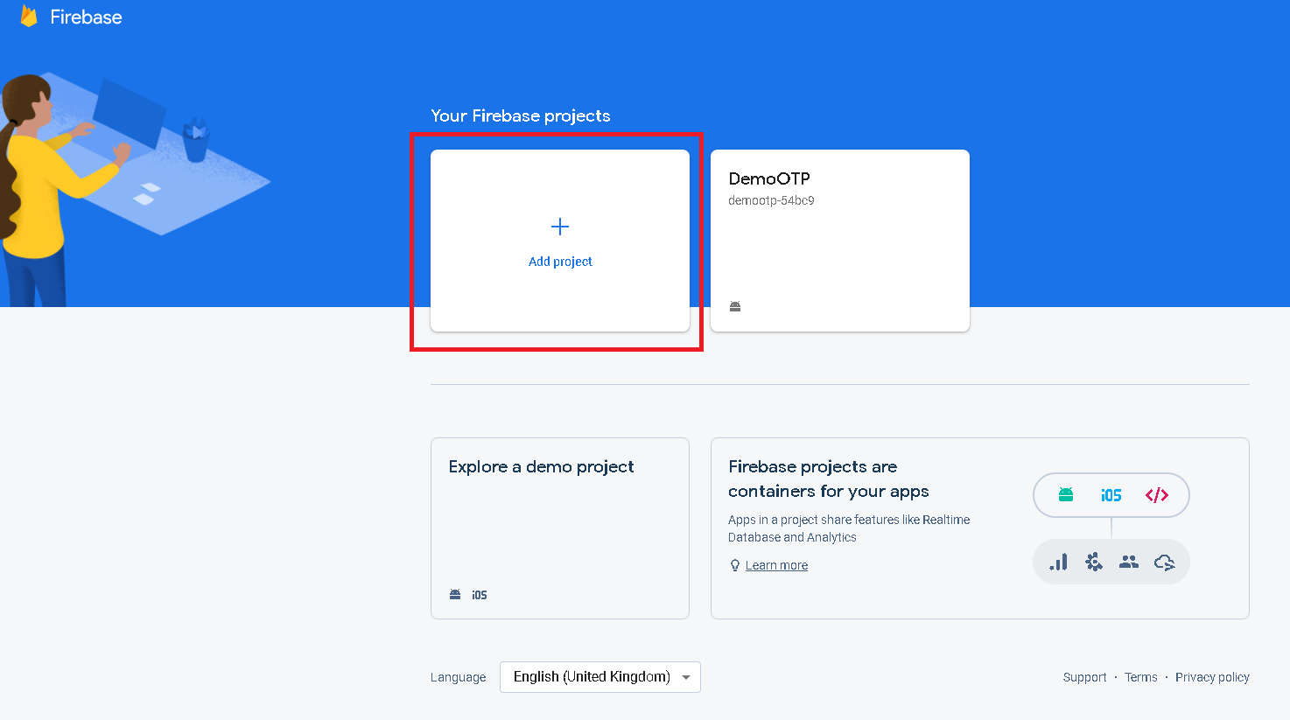

1. After creating a Firebase project navigate to the Authentication tab and turn on phone login in the sign-in method

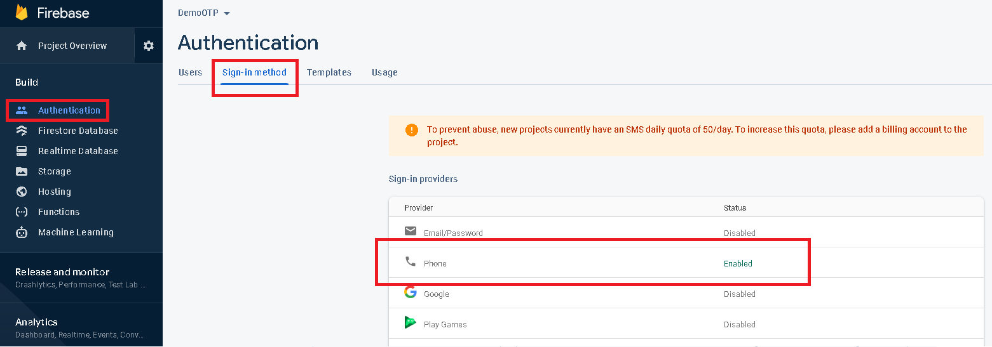

1. Then navigate back to Project Overview and Add a new Android app to your project

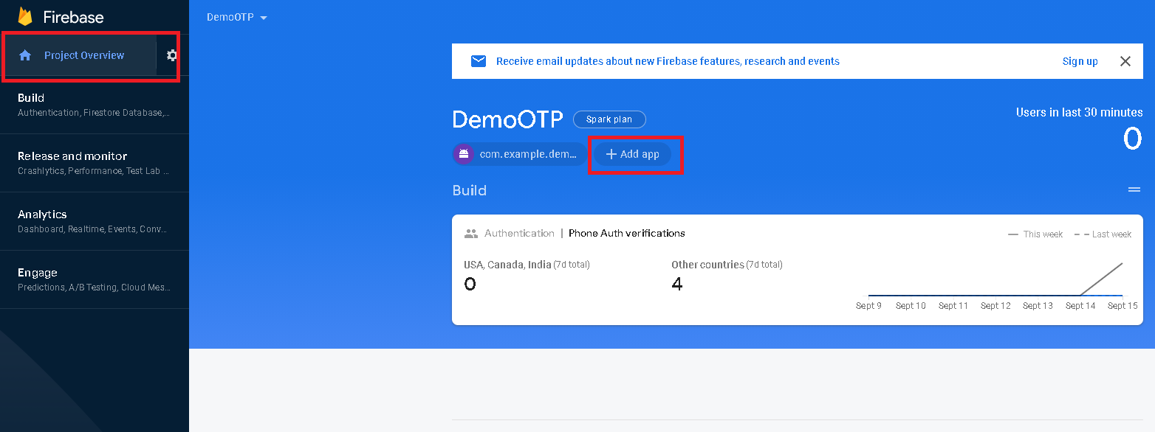

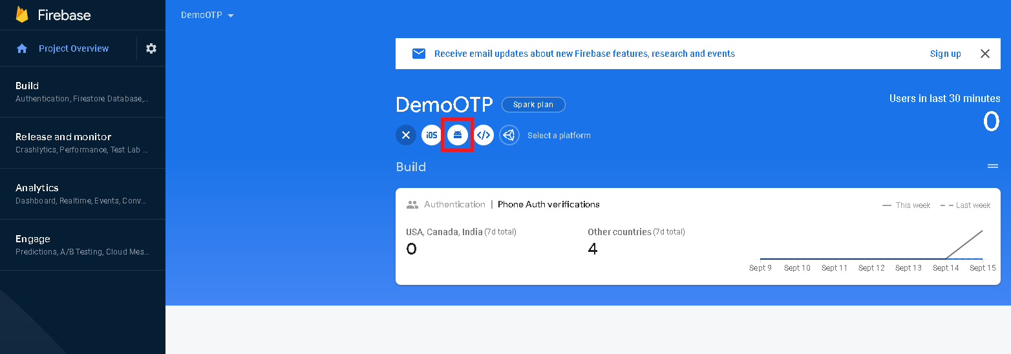

1. Enter the package name with com.example.demootp
2. Choose any nick name

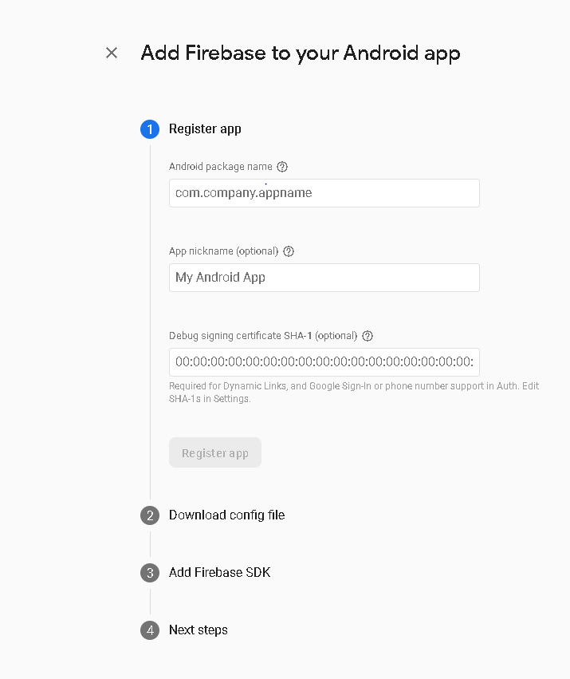

1. Enter your SHA-1 which can be found by opening Gradle task on the right of Android studio and run the signingReport file, the SHA-1 key can be seen under the console

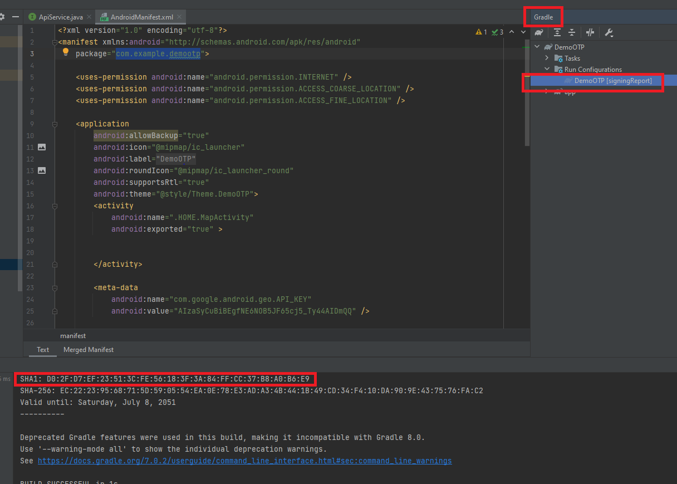

1. Download the google-service.json config file and place it in the app folder of the Android components as shown

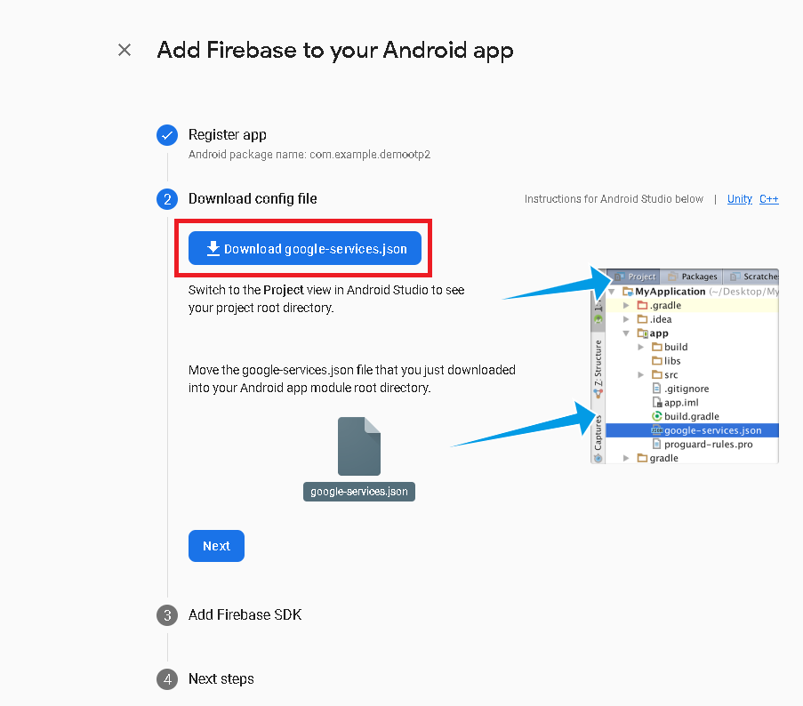

Firebase OTP has been implemented according to your machine’s configuration, you should be able to receive OTP message.